**Sustainable Smart City Assistant Using IBM Granite LLM**

**Project Documentation**

# 1.Introduction

Project title : Sustainable Smart City Assistant Using IBM Granite LLM

* Team member : Udhaya kumar.S
* Team member : Anas khan.S
* Team member : Lokesh.k
* Team member : Bala Barathi.B

# 2.project overview

* Purpose : A Sustainable Smart City is an urban area that integrates technology, data-driven solutions, and eco-friendly practices to improve the quality of life for its citizens while ensuring long-term environmental and economic sustainability. It combines smart infrastructure, renewable energy, efficient resource management, and digital governance to create a connected, green, and resilient city.
* Features:

**Conversational Interface**

*Key Point:* Natural language interaction

*Functionality:* Allows citizens and officials to ask questions, get updates, and receive guidance in plain language

**Policy Summarization**

*Key Point:* Simplified policy understanding

*Functionality:* Converts lengthy government documents into concise, actionable summaries.

**Resource Forecasting**

*Key Point:* Predictive analytics

*Functionality:* Estimates future energy, water, and waste usage using historical and real-time data.

**Eco-Tip Generator**

*Key Point:* Personalized sustainability advice

*Functionality:* Recommends daily actions to reduce environmental impact based on user behavior.

**Citizen Feedback Loop**

*Key Point:* Community engagement

*Functionality:* Collects and analyzes public input to inform city planning and service improvements.

**KPI Forecasting**

*Key Point:* Strategic planning support

*Functionality:* Projects key performance indicators to help officials track progress and plan ahead.

**Anomaly Detection**

*Key Point:* Early warning system

*Functionality:* Identifies unusual patterns in sensor or usage data to flag potential issues.

**Multimodal Input Support**

*Key Point:* Flexible data handling

*Functionality:* Accepts text, PDFs, and CSVs for document analysis and forecasting.

**Streamlit or Gradio UI**

*Key Point:* User-friendly interface

*Functionality:* Provides an intuitive dashboard for both citizens and city officials to interact with the assistant.

# 3.Objectives

# Promote sustainability by reducing carbon footprint and conserving resources.

# Enhance mobility and transport through smart traffic and public transport systems.

# Ensure efficient energy usage with renewable sources like solar and wind.

# Provide smart governance with e-services and transparent administration.

# Improve healthcare, education, and safety using IoT, AI, and data analytics.

# Encourage citizen participation in decision-making.

# 

4. Key Components

1. Smart Infrastructure – IoT-enabled buildings, smart grids, and eco-friendly construction.
2. Energy Management – Solar panels, wind farms, and smart meters for energy efficiency.
3. Water & Waste Management – Smart sensors for water usage, recycling, and waste-to-energy plants.
4. Smart Transportation – Electric vehicles, intelligent traffic systems, and smart parking.
5. Digital Governance – Online citizen services, AI-based administration, and open data platforms.
6. Green Spaces & Environment – Urban forests, vertical gardens, and pollution monitoring.
7. Security & Healthcare – Smart surveillance, telemedicine, and AI-driven health monitoring.

## 5.Technologies Used

## IoT (Internet of Things): Smart sensors for monitoring and automation.

## AI & Machine Learning: Predictive analysis for traffic, healthcare, and energy.

## Big Data & Cloud: Data collection, storage, and real-time decision-making.

## Blockchain: Secure digital transactions and governance.

## Renewable Energy Tech: Solar panels, wind turbines, and energy storage systems.

## 6. User Interface

The interface is minimalist and functional, focusing on accessibility for nontechnical users. It includes:

Sidebar with navigation

KPI visualizations with summary cards

Tabbed layouts for chat, eco tips, and forecasting

Real-time form handling

PDF report download capability

The design prioritizes clarity, speed, and user guidance with help texts and intuitive flows.

## 7. Testing

Testing was done in multiple phases:

Unit Testing: For prompt engineering functions and utility scripts

API Testing: Via Swagger UI, Postman, and test scripts

Manual Testing: For file uploads, chat responses, and output consistency

Edge Case Handling: Malformed inputs, large files, invalid API keys

Each function was validated to ensure reliability in both offline and APIconnected modes.

**8.screen shots**

**Choosing a IBM Granite model From Hugging Face.**

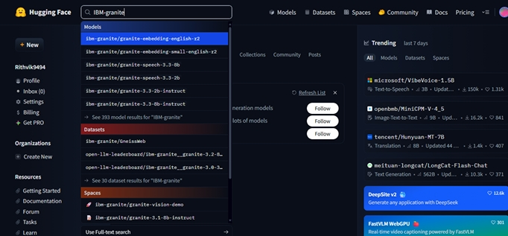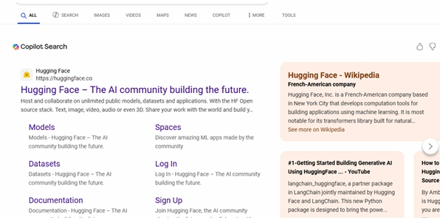

**●Here for this project we are using“granite-3.2-2b-instruct” which is compatible fast and light weight.**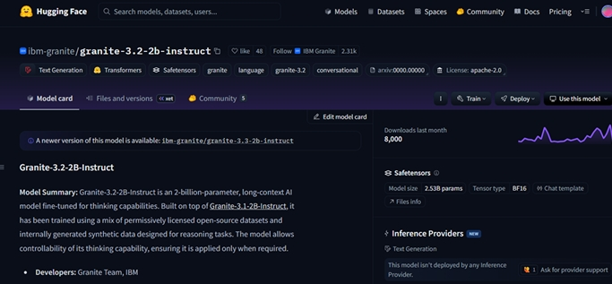

**● Now we will start building our project in Google collab.**

**Running Application in Google Collab.**

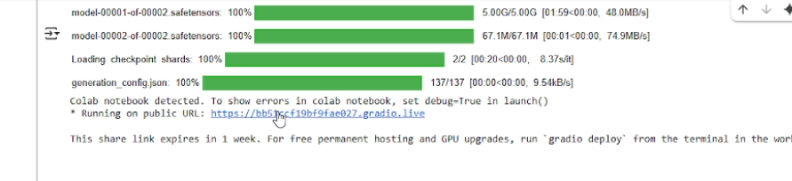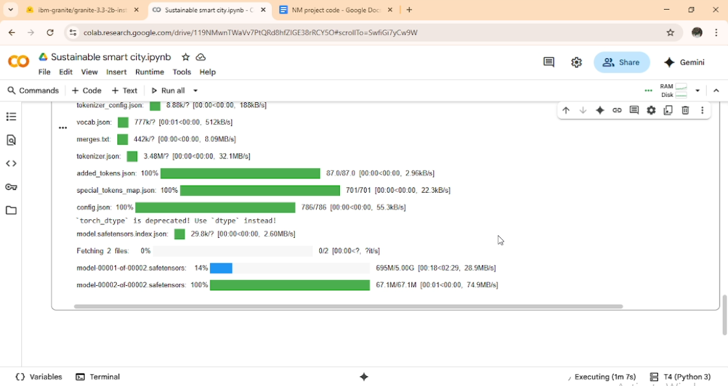

**The Application is the running in the other tab**

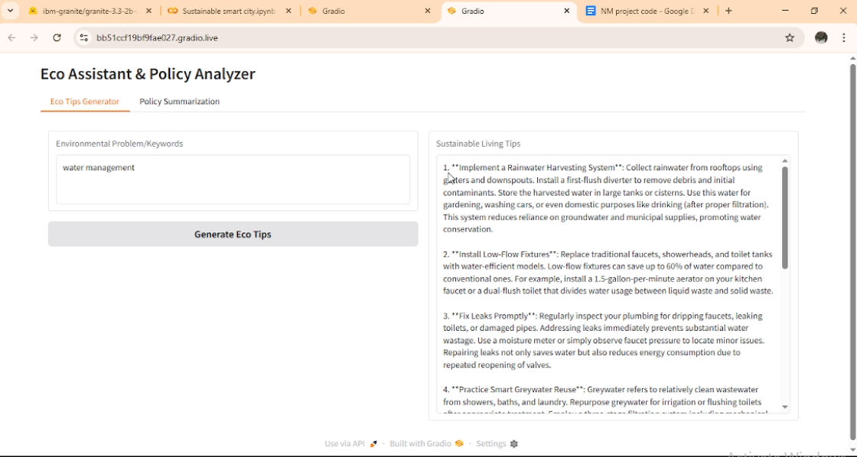

**9.Known Issues**

**1. Data Integration & Interoperability**

Smart cities collect data from IoT sensors, traffic systems, utilities, etc.

Problem: Different devices and platforms (legacy + modern) may not integrate smoothly, even with IBM’s cloud/IoT platforms.

2. High Implementation Cost

IBM technologies (Watson, Granite LLM, IoT, blockchain) require large investments in infrastructure, cloud, and training.

Smaller municipalities struggle with budgeting.

3. Cybersecurity & Privacy Concerns

Citizen data (traffic, health, energy usage) is sensitive.

Even with IBM’s advanced AI Security & QRadar tools, risks like hacking, surveillance misuse, and data leaks remain.

4. Scalability Challenges

IBM solutions perform well at pilot scale, but when scaled to an entire city, network bandwidth, storage, and latency issues appear.

5. Skill Gap & Training

Running AI-driven sustainable systems requires expertise in cloud, IoT, machine learning, and IBM-specific tools.

Cities often lack trained professionals.

10.future enhancement

1. AI-Driven Decision Making

Use Granite LLM + Watson AI for predictive governance (traffic control, disaster management, energy usage).

AI chatbots/assistants for 24×7 citizen services (queries on waste pickup, electricity, water usage, etc.).

2. Green Energy Integration

Smarter integration of solar, wind, and bio-energy into grids.

AI-based demand forecasting to reduce fossil fuel dependency.

3. Digital Twin Technology

Create virtual models of cities to simulate traffic, energy, pollution, and climate effects before making real changes.

IBM’s IoT + Cloud platforms can power these simulations.

4. Blockchain for Transparency

Use blockchain to ensure secure, transparent transactions in utilities (water, electricity billing, smart contracts for waste management).

5. Autonomous & Sustainable Transport

Expansion of EVs, self-driving buses, and smart charging stations.

AI-driven traffic rerouting to minimize congestion and emissions.